Land Value AI**BETA**

*API Documentation*

*2020*

# Service Overview

The Ag-Analytics® Land Value AI provides timely and accurate estimation of any given parcel on any specific day. The current version of Land Value has two types of estimations: Auto Comps takes the comparables referring to properties with characteristics that are similar to the target parcel whose value is being estimated. AI models were trained on the real historical and near-real-time climate, agriculture, and economic data. It provides a science-based and big-data-based estimations on the parcel value.

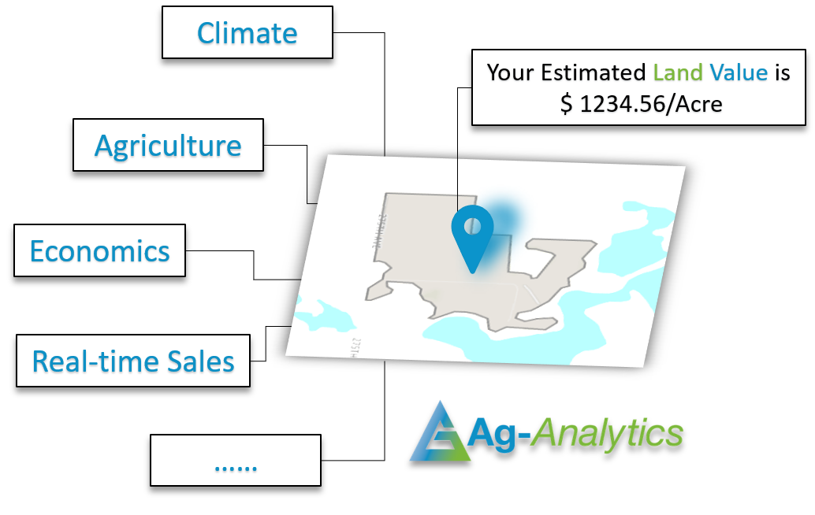

# Model Specifications

## The real farmland sales information which both estimations – Auto Comps and AI Models of the Land Value AI are developed upon is powered by [FarmlandFinder](https://www.farmlandfinder.com/). Besides the real-time parcel sales information, AL models take three factors into the model training which are Climate, agriculture data, and the most up to date economic data.

## **AI Model Data Overview**

|  |  |  |  |
| --- | --- | --- | --- |
| **Factor** | **Variables** | **Data Retrieved Time** | **Description** |
| **Sales** | Location | NA | Location is critical in the parcel/land value estimation. Farmlands sold in Florida may have quite different prices as farmlands in Minnesota. |
| Area | NA |
| Price | NA |
| **Climate** | PRISM | Monthly Average of 30 years | The local climate may also affect the farmland basic characteristics which largely determine that land values. PRISM provides the monthly average temperature and precipitation in the past 30 years by the sold year. CMIP5Climate provides the projection weather in 2050 and 2070. |
| CMIP5Climate | Monthly Average in 2050, and 2070 |
| **Agriculture** | CDL | The past 5 years | Crop rotation, productivity indexes, and elevation are the most important characteristics of the farmland parcels. The variables in this category reflect the productivity and fertility of the parcels. For example, National Commodity Crop Productivity Index (NCCPI) indicates the productivity of the soil.  The source of Elevation is from USGS 10-meter Digital Elevation Model. Associated Elevation/ Topology indexes are calculated with Ag-Analytics Elevation Index API. These indexes provide the local elevation variance.(For further description of the [DEM Service API](https://ag-analytics.developer.azure-api.net/api-details#api=dem-service&operation=dem-service) and [Elevation Index API](https://ag-analytics.developer.azure-api.net/api-details#api=elevation-index&operation=elevation-index), please check out [Ag-Analytics API developer portal](https://ag-analytics.developer.azure-api.net/).) |
| Soil pH | NA |
| National Commodity Crop Productivity Index (NCCPI) | NA |
| Elevation and Indexes | NA |
| **Economics** | Treasury | One year after sale year | Land value is largely influenced by the market. For example, if the next year’s corn futures settlement price is higher than it in last month, then the corn price is expected to be higher next year. It is likely to make the corn farmland price higher compared to the price of this farmland last month. |
| Commodity futures | One year after sale year |
| Federal Interests Rate | One year after sale year |

## **Auto Comps Overview**

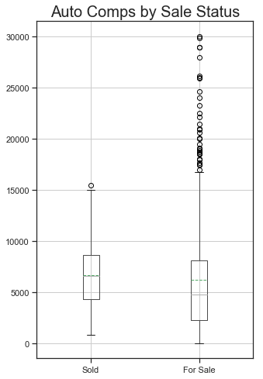 Comparables(Comps) is the term used on real estate appraisal. It refers to the properties within certain query criteria that have similar characteristics to the target property whose value is being sought. Auto Comps in Ag-Analytics® Land Value AI is based on near real-time farmland sales information. It will automatically match the properties having similar geographical and temporal characteristics with the target land/parcel. Geographically, the Auto Comps will only get the lands/parcels located within a certain distance and filter out the lands/parcels that are far away from the target. After applied the geographic filter, Auto Comps will generate a 180-day searching window as the temporal filter which is based on the expected sale date user passed in. Then The temporal filter will exclude any lands/parcel with listing/sold time are not in this 180-day window. The unit of results is $/acre. The results will be grouped by sale condition which is either ‘Sold’ or ‘For Sale’. Additional statistical information of the price is also provided in the results.

Figure 1 Auto Comps Results Boxplot

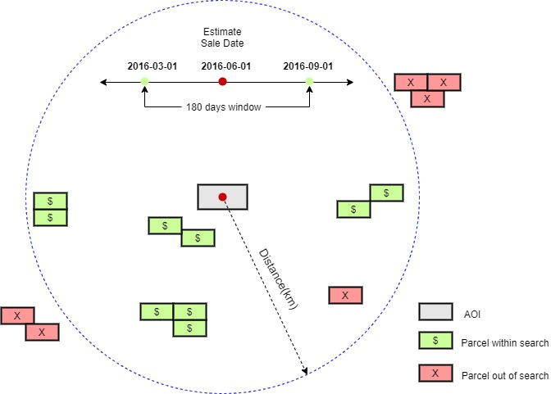

Figure 2 Illustration of Auto Comps Filters

# POST Request

API: [Here](https://ag-analytics.portal.azure-api.net/docs/services/tillage-model/operations/tillage-identification)

Header Parameters Execute Type: POST

content-type: "application/json”

# API Specifications

## **Request Parameters**

|  |  |  |  |  |  |
| --- | --- | --- | --- | --- | --- |
| **Parameter** | **Data Type** | **Required**? | **Default** | **Options** | **Description** |
| **aoi** | GeoJSON in string | Yes | - | - | Geometry of area of Interest in GeoJSON format. Need to be passed into the API as string |
| **model** | String | No | Linear | ‘Linear’, ’Tree’,  ’RF’,  ’Auto’ | Model options:  Linear: Multiple Linear Regression  Tree: Decision Tree Regression  RF: Random Forest Regression  Auto: Auto Comps |
| **Sale_Date** | String | Yes | - | - | Expected sale date in ‘yyyy-mm-dd’ format. EX: ‘2020-04-20’ |

## **Response Parameters**

|  |  |  |
| --- | --- | --- |
| **Parameter** | **Type** | **Description** |
| **Model** | String | Model name of Land Value. ‘Auto’ |
| **status** | String | Status of the API call. ‘SUCCESS’ or ‘FAILED’ |
| **msg** | String | The error message when API call failed |
| **Result** | Dictionary/float | Result of the Land value AI. In Auto Comps, the Result is a dictionary. The results will be grouped by sale condition: ‘Sold’ or ‘For Sale’ |
| **Parameters in Result** |  |  |
| **Parcel_Area** | Float | Parcel area in acreage. |
| **Total_Price** | Float | Total estimated price of the entire parcel |
| **Sale_Date** | String | Estimated sale date. User specified |
| **Unit** | String | Unit of price. Currently default as us dollars |
| **Price_Acre** | Float | AI Estimated Price per acre |
| **Percentile_10\*** | Float | The 10% percentile price per acre in the Auto Comps searching scope from low to high |
| **Percentile_90\*** | Float | The 90% percentile price per acre in the Auto Comps searching scope from low to high |
| **avg_price\*** | Float | Average price per acre in the Auto Comps searching scope |
| **max_price\*** | Float | Highest price per acre in the Auto Comps searching scope |
| **min_price\*** | Float | Lowest price per acre in the Auto Comps searching scope |
| **num_list\*** | Integer | Number of comparables within the Auto Comps searching scope |

Note: Parameters with * are results in Auto Comps model

# Appendix

### **Figure 1** – Shape Example, GeoJSON

### **Figure 2** – POST Request Example

### **Figure 3** – POST Response Example of Auto Comps

**Figure 4 –** POST Response Example of AI Models

Figure 1.

*Shape Example - GeoJSON*

|  |
| --- |
|  |
| "{\"type\":\"Feature\",\"properties\":{},\"geometry\":{\"type\":\"Polygon\",\"coordinates\":[[[-95.84165811538698,46.30405964827517],[-95.84174394607544,46.29697349504195],[-95.83659410476686,46.29691419281915],[-95.83655118942261,46.29814470078284],[-95.83831071853638,46.29817435123596],[-95.83837509155275,46.3029330408763],[-95.83831071853638,46.30303680831659],[-95.83801031112672,46.30296268873647],[-95.837699174881,46.30297010069899],[-95.83699107170106,46.30349634747375],[-95.83695888519289,46.30367423256352],[-95.8370339870453,46.30393364728336],[-95.83717346191408,46.3040003537269],[-95.8375597000122,46.30405223646016],[-95.8375597000122,46.30318504717584],[-95.84077835083009,46.30317022330798],[-95.84081053733827,46.30408188371422],[-95.84165811538698,46.30405964827517]]]}}" |

Figure 2

*Request Example – application/json*

|  |
| --- |
| **application/json**  {'aoi': '{"type":"Feature","properties":{},"geometry":{"type":"Polygon","coordinates":[[[-95.84165811538698,46.30405964827517],[-95.84174394607544,46.29697349504195],[-95.83659410476686,46.29691419281915],[-95.83655118942261,46.29814470078284],[-95.83831071853638,46.29817435123596],[-95.83837509155275,46.3029330408763],[-95.83831071853638,46.30303680831659],[-95.83801031112672,46.30296268873647],[-95.837699174881,46.30297010069899],[-95.83699107170106,46.30349634747375],[-95.83695888519289,46.30367423256352],[-95.8370339870453,46.30393364728336],[-95.83717346191408,46.3040003537269],[-95.8375597000122,46.30405223646016],[-95.8375597000122,46.30318504717584],[-95.84077835083009,46.30317022330798],[-95.84081053733827,46.30408188371422],[-95.84165811538698,46.30405964827517]]]}}',  'model': 'Auto',  'Sale_Date': '2020-04-15'} |
|  |

Figure 3

*Response – application/json*

|  |
| --- |
| {  "Model": "Auto",  "Result": {  "For Sale": {  "Percentile_10": 1285.0,  "Percentile_90": 13255.0,  "avg_price": 4792.197782389308399065,  "max_price": 895000.0000,  "min_price": 26.0000,  "num_list": 811  },  "Parcel_Area": 51.74941101442054,  "Sold": {  "Percentile_10": 3549.0,  "Percentile_90": 11100.0,  "avg_price": 6879.141775894334,  "max_price": 69371.0,  "min_price": 792.0,  "num_list": 318  },  "Unit": "$",  "Sale_Date": "2020-04-15"  },  "status": "SUCCESS"  } |

Figure 4

*Response – application/json*

|  |
| --- |
| '{  "Result": {  "Model": "RF",  "Parcel_Area": 51.74941101442054,  "Price_Acre": 10520.09,  "Sale_Date": "2020-04-15",  "Total_Price": 544408.4613186953,  "Unit": "$"  },  "status": "SUCCESS"  }' |



**Spatial Reference Information:**

Universal Transverse Mercator (UTM) Dominant Zone, North American Datum 1983

Please contact **support@analytics.ag**, **josh@ag-analytics.org**, or **woodardjoshua@gmail.com** with any comments or questions.